
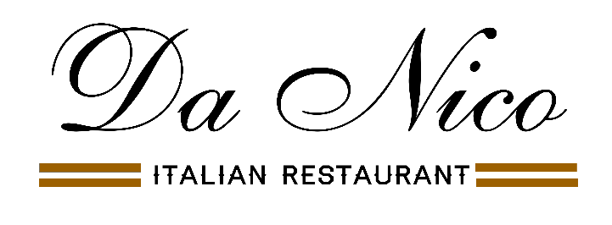

Menu Natale

Zuppa di lenticchie e zucca (v) (gf)*
Red lentil & butternut squash soup

Crostino ai funghi porcini (v)
Toasted bread with porcini mushrooms sauteed with garlic & parsley

Carpaccio di Salmone (gf)*
Smoked salmon with with rocket & lemon zest

Antipasto Italiana (gf)*
Selection of cured meat, cheese & pickles

Cozze alla Messinese (gf)*
Mussels in tomato & chilli sauce sauce served with toasted bread

*****
Risotto vegetali (v) (gf)
Risotto of creamy butternut squash, spinach & peas

Ravioli ai porcini (v)
Fresh pasta filled with porcini mushrooms in a cream & touch of tomato sauce

Arrosto di Tacchino Natalizio (gf)*
Traditional roast turkey with all the trimmings

Tonno (gf)
Tuna steak in a creamy parsley sauce

Bistecca (gf) +£5 supplement
10 oz sirloin steak with choice of sauce
(gorgonzola, peppercorn, mushrooms)

All meat & fish dishes are served with seasonal vegetables & potatoes

*****

Selection of our most popular desserts to choose from
(Cannolo, Rum baba, Profiteroles, Tiramisu, Lemon lime cheesecake, ice cream & sorbet)
2 Courses £32.00
3 Courses £38.50
Christmas crackers on the table

An optional 12.5% service will be added on parties of 6 or more

Menu may be subject to minor adjustment
(v) vegetarian (gf) gluten free (gf)*can be made gluten free

Preorder required on table of 8 or more

